**NATURAL DISASTER INTENSITY ANALYSIS AND CLASSIFICATION USING ARTIFICIAL INTELLIGENCE.**

***DONE BY***

***TEAM ID:* PNT2022TMID06270**

**AKSHARA M(71051902005)**

**HARITHA L(71051902019)**

**JOTHIMEENA V(71051902022)**

**KAVIYA C(71051902026)**

**MONIKA S(71051902029)**

**Project report Submitted in partial fulfillment of the requirements for the award of the degree of**

**BACHELOR OF ENGINEERING**

### In

**COMPUTER SCIENCE AND ENGINEERING**

**COIMBATORE INSTITUE OF ENGINEERING AND TECHNOLOGY(AUTONOMOUS)**

**TABLE OF CONTENT**

## INTRODUCTION

1.1 Project Overview

1.2 Purpose

## LITERATURE SURVEY

2.1 Existing problem

2.2 References

2.3 Problem Statement Definition

## IDEATION & PROPOSED SOLUTION

3.1 Empathy Map Canvas

3.2 Ideation & Brainstorming

3.3 Proposed Solution

3.4 Problem Solution fit

## REQUIREMENT ANALYSIS

4.1 Functional requirement

4.2 Non-Functional requirements

## PROJECT DESIGN

5.1 Data Flow Diagrams

5.2 Solution & Technical Architecture

5.3 User Stories

## PROJECT PLANNING & SCHEDULING

6.1 Sprint planning and estimation

6.2 Sprint delivery Schedule

6.3 Reports from JIRA

## CODING & SOLUTIONING

7.1 Feature 1

7.2 Feature 2

7.2 Database Schema

## TESTING

## 8.1 Test Cases

## 8.2 User Acceptance Testing

## RESULTS

9.1 Performance Metrics

## ADVANTAGES & DISADVANTAGES

**11.CONCLUSION**

**12.FUTURE SCOPE**

**13.APPENDIX**

Source Code

GitHub & Project Demo Link

**1.INTRODUCTION:**

Natural disasters are inevitable, and the occurrence of disasters drastically affects the economy, ecosystem and human life. Buildings collapse, ailments spread and sometimes natural disasters such as tsunamis, earthquakes, and forest fires can devastate nations. When earthquakes occur, millions of buildings collapse due to seismological effects. As the population is growing rapidly, people need to acquire land to live on, and as a result the ecosystem is disturbed horrifically, which causes global warming and increases the number of natural disasters. Populations in underdeveloped countries cannot afford damages disasters cause to infrastructures. The aftermath of disasters leaves the humans in miserable situations, and sometimes the devastating effects cannot be detected; additionally, rescue operations cannot take place in most of the places and victims are unable to be identified due to geographical factors of the different areas.Disasters such as forest fires spread rapidly in dense areas, so firefighting is difficult to carry out; in this case, development of the strategy to predict such circumstances is crucial so that such disasters can be prevented beforehand.As the technologies are continuously improving, aviation systems have begun adopting smart technologies to develop unmanned aerial vehicles (UAVs) equipped with cameras, which can reach distant areas to identify aftereffects of natural disasters on human life, infrastructure, and transmission lines by capturing images and videos. Data acquired from these UAVs helps to identify the facial expressions of victims, the intensity of their situation and their needs in a post disaster scenario. It helps to take actions and carry out necessary operations to tackle devastating scenarios. Raw images obtained from camera-equipped UAVs are processed and neural network-based feature extraction techniques are applied to analyze the intensity.

**1.1 OVERVIEW:**

Natural disasters not only disturb the human ecological system but also destroy the properties and critical infrastructures of human societies and even lead to permanent change in the ecosystem. Disaster can be caused by naturally occurring events such as earthquakes, cyclones, floods, and wildfires. Many deep learning techniques have been applied by various researchers to detect and classify natural disasters to overcome losses in ecosystems, but detection of natural disasters still faces issues due to the complex and imbalanced structures of images. To tackle this problem, we developed a multilayered deep convolutional neural network model that classifies the natural disaster and tells the intensity of disaster of natural.The model uses an integrated webcam to capture the video frame and the video frame is compared with the Pre-trained model and the type of disaster is identified and showcased on the OpenCV window. A deep learning method for the construction of two-dimensional cardiac magnetic resonance images was proposed to enhance the image data acquisition process.

**1.2 PURPOSE:**

The main purpose of this model is to detect and classify the type of disaster with a high accuracy rate and to prevent the natural disaster in real time.This method include the use of artificial intelligence which, given its ability to anticipate future events, could make a huge difference and help limit the human and material costs of such disasters.Artificial intelligence is proving to be a valuable tool for detecting and analysing the first signs of these types of events.This model is capable of providing a level of accuracy close to that of human analyses and of detecting a larger number of Disaster, particularly those of low intensity, which are usually not identified by traditional detection methods. This increased detection power has been achieved by adapting the best medical image processing and voice capture algorithms to detect even the weakest of signals. Being able to identify and then study the smallest disasters is of considerable interest; this provides a better overall understanding of how these events are distributed along a fault line, and also helps learn more about how they are triggered and how they stop.

**2. LITERATURE SURVEY:**

**2.1 EXISTING PROBLEM:**

Over the past century, techniques for monitoring, forecasting and managing natural disasters have developed considerably as a result of technological progress.major obstacle: high-magnitude earthquakes – the ones that seismologists would most like to be able to predict – are also the rarest, due to the exceptional nature of the conditions required for them to occur. This raises the problem of the lack of data needed to train the algorithm properly.Conversely, small, imperceptible Disaster occur daily, along the same fault lines from which high-intensity events originate and, moreover, they involve identical physics and mechanisms. These “micro-earthquakes” therefore represent a useful source of untapped information in the quest to understand and predict Disaster.

**2.2 REFERENCES:**

[1]Ashiquzzaman A., Oh S.M., Lee D., Lee J., Kim J. *Smart Trends in Computing and Communications, Proceedings of the SmartCom 2020, Paris, France, 29–31 December 2020.* Springer; Berlin/Heidelberg, Germany: 2021. Context-aware deep convolutional neural network application for fire and smoke detection in virtual environment for surveillance video analysis; pp. 459–467.

[2]Amit S.N.K.B., Aoki Y. Disaster detection from aerial imagery with convolutional neural network; Proceedings of the 2017 International Electronics Symposium on Knowledge Creation and Intelligent Computing (IES-KCIC); Surabaya, Indonesia. 26–27 September 2017; pp. 239–245.

[3]Hartawan D.R., Purboyo T.W., Setianingsih C. Disaster Victims Detection System Using Convolutional Neural Network (CNN) Method; Proceedings of the 2019 IEEE International Conference on Industry 4.0, Artificial Intelligence, and Communications Technology (IAICT); Bali, Indonesia. 1–3 July 2019; pp. 105–111.

[4] Islam A.R.M.T., Talukdar S., Mahato S., Kundu S., Eibek K.U., Pham Q.B., Kuriqi A., Linh N.T.T. Flood susceptibility modelling using advanced ensemble machine learning models. *Geosci. Front.* 2021;**12**:101075. doi: 10.1016/j.gsf.2020.09.006.

[5] Li T., Zhao E., Zhang J., Hu C. Detection of Wildfire Smoke Images Based on a Densely Dilated Convolutional Network. *Electronics.* 2019;**8**:1131. doi: 10.3390/electronics8101131.

[6] Mangalathu S., Burton H.V. Deep learning-based classification of earthquake-impacted buildings using textual damage descriptions. *Int. J. Disaster Risk Reduct.* 2019;**36**:101111. doi: 10.1016/j.ijdrr.2019.101111.

[7] Tonini M., D’Andrea M., Biondi G., Degli Esposti S., Trucchia A., Fiorucci P. A Machine Learning-Based Approach for Wildfire Susceptibility Mapping. The Case Study of the Liguria Region in Italy.*Geosciences.* 2020;**10**:105. doi: 10.3390/geosciences10030105.

[8] Tang C., Zhu Q., Wu W., Huang W., Hong C., Niu X. PLANET: Improved convolutional neural networks with image enhancement for image classification.*Math.Probl.Eng.* 2020;2020 doi: 10.1155/2020/1245924.

**2.3 PROBLEM STATEMENT DEFINITION:**

The problem affects in the case that Natural disasters not only disturb the human ecological system but also destroy the properties and critical infrastructures of human societies and even lead to permanent change in the ecosystem.The main cause for disaster is it can be caused by naturally occurring events such as earthquakes, cyclones, floods, and wildfires.Critical impact is,Since most of the disaster are naturally occurring, if cannot be avoided. The caution of the natural disaster will be more which can be reduced by some precautionary measures.To avoid this the role of artificial intelligence in such disasters is required and important for analysing the situations and to come out with solutions for being prepared to face disasters.And Thus, the challenges for artificial intelligence are cost, saving life, environment protection and false data.Therefore, the main issue is that Many deep learning techniques have been applied by various researchers to detect and classify natural disasters to overcome losses in ecosystems, but detection of natural disasters still faces issues due to the complex and imbalanced structures of images.Neural networks provide multilevel network architectures, where Convolutional Neural Networks are the most frequently implemented architecture as the direct input of multidimensional vector images, can be carried out with low complexity. CNNs efficiently perform feature extraction by denoising the images and removing interference and achieve highly accurate results.

**3. IDEATION AND PROPOSED SOLUTION:**

**3.1 EMPATHY MAP CANVAS: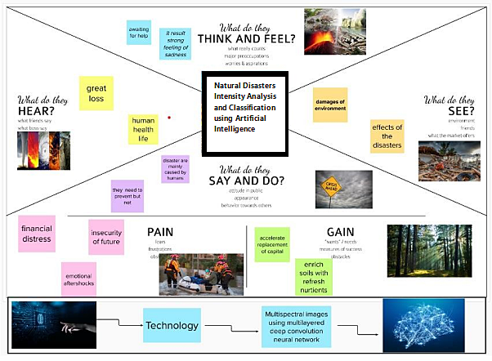3.2 IDEATION AND BRAINSTORMING:**

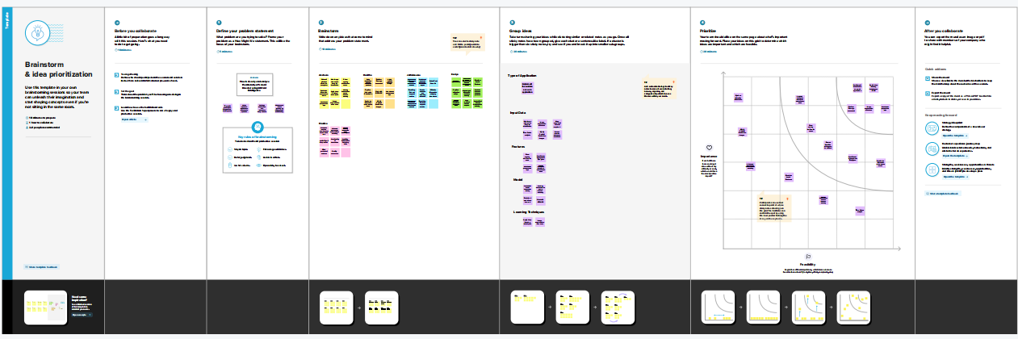

**3.3 PROPOSED SOLUTION:**

|  |  |  |
| --- | --- | --- |
| **S.No.** | **Parameter** | **Description** |
| 1. | **Problem Statement (Problem to be solved)** | To Classify and analyze the intensity of natural disasters before and after hand to alert and protect livelihood and its associated factors. |
| 2. | **Idea / Solution description** | To develop a multi-layered deep convolutional neural network model that classifies the natural disaster and tells the intensity of disaster. An integrated webcam is used to capture the video frame and the video frame is compared with the pre-trained model. The type of disaster is identified and showcased on the OpenCV window. |
| 3. | **Novelty / Uniqueness** | A web app interface to feed live video stream or recorded content to identify the intensity level of the disaster at a particular location and an alerting system. |
| 4. | **Social Impact / Customer Satisfaction** | Continuous monitoring service and accurate detection of the natural disaster with an alerting system based on the level of intensity reduces damage done to livelihood and economy. |
| 5. | **Business Model (Revenue Model)** | A lightweight , robust and portable prototype with accurate, reliable and advanced analysis of a natural disaster with Multi-Layer CNN at its heart. Includes a Web-cam that detects complex and imbalanced structures of images which is then compared with the pre-trained model and the type of disaster is identified. |
| 6. | **Scalability of the Solution** | The model prototype can be extended to private and government forecast organisations which can help in global recognition, due to its robustness and portability. |

**3.4 PROBLEM SOLUTION FIT:**

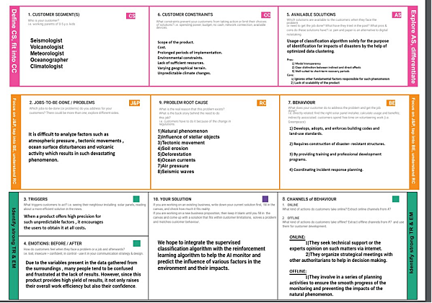

**4.REQUIREMENT ANALYSIS:**

**4.1 FUNCTIONAL REQUIREMENTS:**

|  |  |  |
| --- | --- | --- |
| **FR No.** | **Functional Requirement (Epic)** | **Sub Requirement (Story / Sub-Task)** |
| FR-1 | Request Permission | Access permission from web camera. |
| FR-2 | Disaster Prediction | Based on the webcam image, natural disaster is classified. |
| FR-3 | Accuracy | Since the training and testing images are huge, the accuracy is higher. |
| FR-4 | Speed | The generation of results from the input images are faster. |
| FR-5 | Resolution | The resolution of the integrated web camera should be high enough tocapturethe video  frames. |
| FR-6 | User Interface | Maximizing the interaction in Web Designing Service. |

**4.2 NON-FUNCTIONAL REQUIREMENTS:**

|  |  |  |
| --- | --- | --- |
| **FR No.** | **Non-Functional Requirement** | **Description** |
| NFR-1 | **Usability** | User friendly and classify the disaster easily. |
| NFR-2 | **Security** | The model is secure due to the cloud deployment models and also there is no login issue. |
| NFR-3 | **Reliability** | Accurate prediction of the natural disaster and the website can also be fault tolerant. |
| NFR-4 | **Performance** | It is shown that the model gives almost 90 percent accuracy after continuous training. |
| NFR-5 | **Availability** | The website will be made available for 24 hours. |
| NFR-6 | **Scalability** | The website can run on web browsers like Google chrome, Microsoft edge and also it can be extended  to the NDRF and customers. |

**5. PROJECT DESIGN:**

**5.1 DATAFLOW DIAGRAM:**

A data flow diagram (DFD) is a visual representation of the information flow through a process or system. DFDs help Us better understand process or system operation to discover potential problems, improve efficiency, and develop better processes.

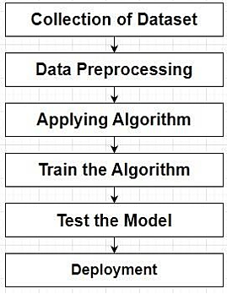

**5.2 SOLUTION AND TECHNICAL ARCHITECTURE:**

**SOLUTION ARCHITECTURE:**

Solution architecture is a complex process – with many sub-processes - that bridges the gap between business problems and technology solutions. Its goals are to:

1. Find the best tech solution to solve existing business problems.
2. Describe the structure, characteristics, behavior, and other aspects of the software to project stakeholders.
3. Define features, development phases, and solution requirements.
4. Provide specifications according to which the solution is defined, managed, and delivered.

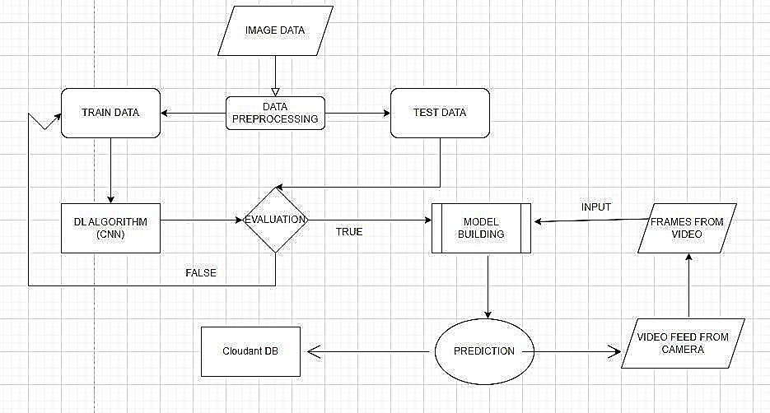

**TECHNICAL ARCHITECTURE:**

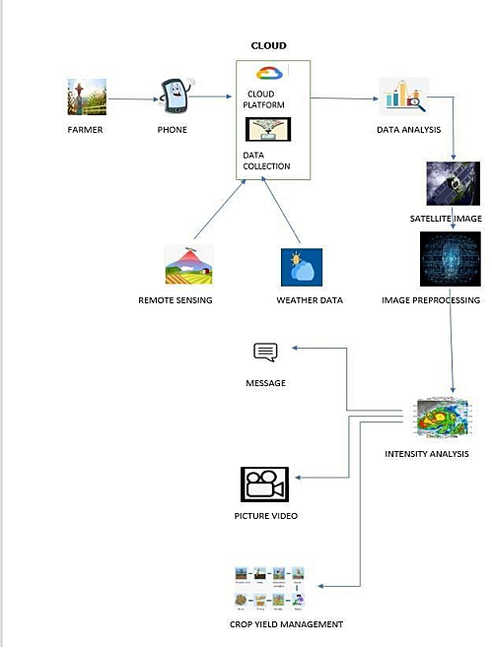

|  |  |  |  |
| --- | --- | --- | --- |
| **S. No** | **Component** | **Description** | **Technology** |
| 1 | Website | Customer can proceed the website and interact with the chatbot to get the desire  product | HTML, CSS, JavaScript, chatbot |
| 2 | Docker | Service for storing the private container  images | Container |
| 3 | IBM Object Storage | Bucket are used to upload the images and files | Bucket |
| 4 | Kubernetes | Manage the complete process in the stable state  If any software crash it automatically restart the  work | Kubernetes |
| 5 | DB2 | Data types are String, Numeric, Date, time, and timestamp distinct types.Act_ sortmem_ limit, auto_ del_ rec _ obj,  auto_ maint Configuration . | MySQL |
| 6 | Cloud DB2 | A fully managed cloud database with AI capabilities that keep our website running  24*7. | IBM DB2 |
| 7 | Watson chatbot | Customers can search the product easily by  human-like interaction with bot. | IBM Watson Assistant |
| 8 | Infrastructure (Server / Cloud) | Application Deployment on Local System / Cloud  Local Server Configuration: Anaconda  Cloud Sever Configuration: IBM cloud | Local,CloudFoundry, Kubernetes, etc. |

**5.3 USER STORIES:**

|  |  |  |  |  |  |  |
| --- | --- | --- | --- | --- | --- | --- |
| **User Type** | **Functional Requirement**  **(Epic)** | **User Story Number** | **User Story / Task** | **Acceptance criteria** | **Priority** | **Release** |

|  |  |  |  |  |  |  |
| --- | --- | --- | --- | --- | --- | --- |
| Customer (Mobile user) | Registration | USN-1 | As a user, I can register for the application by  entering my email, password, and confirming my password. | I can access my account / dashboard | High | Sprint-1 |
|  |  | USN-2 | As a user, I will receive confirmation email  once I have registered for the application | I can receive confirmation  email & click confirm | High | Sprint-1 |
|  |  | USN-3 | As a user, I can register for the application through Facebook | I can register & access the dashboard with Facebook Login | Low | Sprint-2 |
|  |  | USN-4 | As a user, I can register for the application through Gmail | I can register & access the dashboard with Gmail  Login | Medium | Sprint-1 |
|  | Login | USN-5 | As a user, I can log into the application by entering email & password | I can login & access my  account with my registered credentials | High | Sprint-1 |
|  | Dashboard | USN-6 | As a user, I can access the services and information provided in the dashboard | I can upload the images, I can viewthe result, I can edit my profile and I can view my history | High | Sprint-1 |
| Customer (Web user) | Login | USN-7 | As a user, I can log into the web application and access the dashboard | I can login with the same registered credentials and access my account  through web Application | High | Sprint-1 |

|  |  |  |  |  |  |  |
| --- | --- | --- | --- | --- | --- | --- |
| **User Type** | **Functional Requirement**  **(Epic)** | **User Story**  **Number** | **User Story / Task** | **Acceptace criteria** | **Priorty** | **Release** |
| Customer Care Executive | Help Desk | USN-8 | As a user, I can get the guidance from the customer care | I can get help from the  customer care for carrying out my tasks | High | Sprint-2 |
| Administrator | Management | USN-9 | As an administrator, I can collect new datasets and keep the model trained | I can collect and train the model with new dataset  frequently | High | Sprint-2 |
|  |  | USN-10 | As an administrator, I can update other features of the application | I can update and tune the  features of application if needed | Medium | Sprint-1 |
|  |  | USN-11 | As an administrator, I can maintain the information about the user | I can maintain information like user type and other  such information | Medium | Sprint-1 |
|  |  | USN-12 | As an administrator, I can maintain third-party  services | I can support and maintain  any third-party services | Low | Sprint-2 |

**6. PROJECT PLANNING & SCHEDULING:**

**6.1 SPRINT PLANNING AND ESTIMATION:**

|  |  |  |  |  |  |  |
| --- | --- | --- | --- | --- | --- | --- |
| **Sprint** | **Functional Requirement (Epic)** | **User Story Number** | **User Story / Task** | **Story Points** | **Priority** | **Team Members** |
| Sprint-1 | Registration | USN-1 | As a user, I Collecting data from trusted sources, in addition to collecting analysis. | 2 | High | 1.Akshara.M 2.Haritha.L 3.Jothimeena.V  4.Kaviya.C 5.Monika.S |
| Sprint-1 |  | USN-2 | As a user, I Filtering of demographic information, as well as filtering of countries , region, state ,or province with cases  of disaster | 1 | High | 1.Akshara.M 2.Haritha.L 3.Jothimeena.V 4.Kaviya.C  5.Monika.S |
| Sprint-2 |  | USN-3 | As a user, I Counting, globally or from a specific location ,of confirmed cases,  Recovered and deaths by Disaster | 2 | Low | 1.Akshara.M 2.Haritha.L 3.Jothimeena.V  4.Kaviya.C 5.Monika.S |
| Sprint-1 |  | USN-4 | As a user, I can register for the application through maps | 2 | Medium | 1.Akshara.M 2.Haritha.L 3.Jothimeena.V 4.Kaviya.C  5.Monika.S |
| Sprint-1 | Login | USN-5 | As a user, I can log into the application by entering geographic panel | 1 | High | 1.Akshara.M 2.Haritha.L 3.Jothimeena.V 4.Kaviya.C  5.Monika.S |
| Sprint-2 | Dashboard | USN-6 | As a user, I Display of maps, histograms, or an  interactive geographic panel | 1 | High | 1.Akshara.M 2.Haritha.L |
| Sprint-3 | Prediction and analysis of data | USN – 7 | Predicting and visualizing the data effectively | 6 | High | 1.Haritha L  2.Monika s |
| Sprint-3 | Report generation | USN – 8 | Generating a clear and detailed report on product data analysis | 3 | High | 1.Haritha L  2.Akshara M |
| Sprint-4 | Cloud | USN – 9 | The application is deployed through cloud | 10 | High | 1.Kaviya C  2.Jothimeena V |
| Sprint-4 | Testing | USN – 10 | The system is thoroughly tested and unit testing, integration testing and system testing is  performed | 10 | High | 1.Haritha L  2.Kaviya C  3.Monika S  4.Akshara M  5.Jothimeena V |
| Sprint-4 | Visualizaz on | USN – 11 | The output is shown through simple visualization | 5 | Medium | 1.Kaviya C |

**6.2 SPRINT DELIVERY SCHEDULE:**

|  |  |  |  |  |  |
| --- | --- | --- | --- | --- | --- |
| **Sprint** | **Total Story Points** | **Duration** | **Sprint Start Date** | **Sprint End Date (Planned)** | **Sprint Release Date (Actual)** |
| Sprint-1 | 20 | 6 Days | 24 Oct 2022 | 29 Oct 2022 | 30 Oct 2022 |
| Sprint-2 | 20 | 6 Days | 31 Oct 2022 | 05 Nov 2022 | 06 Nov 2022 |
| Sprint-3 | 20 | 6 Days | 07 Nov 2022 | 19 Nov 2022 | 19 Nov 2022 |
| Sprint-4 | 20 | 6 Days | 14 Nov 2022 | 19 Nov 2022 | 19 Nov 2022 |

**6.3 REPORTS FROM JIRA:**

**7.CODING AND SOLUTIONING:**

**7.1 Feature 1:**

A convolutional neural network is a class of Artificial neural network.It is a Deep Learning algorithm that can take in an input image, assign importance to various objects in the image and be able to differentiate one from the other. The pre-processing required in a ConvNet is much lower as compared to other classification algorithms.The advantage of CNNs is to provide an efficient dense network which performs the prediction or identification efficiently.

**7.2 Feature 2 :**

We developed a multilayered deep convolutional neural network model that classifies the natural disaster and tells the intensity of disaster of natural The model uses an integrated webcam to capture the video frame and the video frame is compared with the Pre-trained model and the type of disaster is identified and showcased on the OpenCV window. A multilayer neural network with appropriate weights has been shown **to be able to approximate any input-output function making it an attractive tool for modeling and forecasting**.

**8. TESTING**

**8.1 Test Cases**

|  |  |  |  |  |  |  |  |  |  |  |  |  |  |
| --- | --- | --- | --- | --- | --- | --- | --- | --- | --- | --- | --- | --- | --- |
|  |  |  |  | Team ID | PNT2022TMID06270 |  |  |  | |  |  |  |  |
| Project Name | Project - Natural Disaster Intensity  Analysis and Classification using  Artificial  Intelligence |
| Maximum Marks | 4 marks |
| **Test case ID** | **Feature Type** | **Component** | **Test Scenario** | **Pre-Requisite** | **Steps To Execute** | **Test Data** | **Expected Result** | **Actual Result** | **Status** | **Comments** | **TC for Automation(Y/N)** | **BUG ID** | **Executed By** |
| HomePage_TC_OO1 | UI | Home Page | Verify user is able to see the home page and other tabs , when user entered into the website | internet and device | 1.Enter URL and click go  2.click the tabs in the Navigation Bar | URL FOR THE WEBSITE | Website should be visible | Working as expected | Pass | NA | N | NA | Kaviya C ,Akshara M, Jothi Meena V, Monika S ,Haritha L |
| HomePage_TC_OO2 | UI | Home Page | verify user is able to see the results tab |  | 1.Enter URL and click go  2.Click on results tab and check whether the user is able to see the flag card with open button | URL FOR THE WEBSITE | Application should show below UI elements:  a.header with live stream   1. a camera glyphicon 2. a button named open | Working as expected | Pass | NA | N | NA | Kaviya C ,Akshara M, Jothi Meena V, Monika S ,Haritha L |
| HomePage_TC_OO3 | Functional | Home page | Verify user is able to click the button on the results tab |  | 1.Enter URL and click go  2.Click on results tab and check whether the user is able to click the button named open | URL FOR THE WEBSITE | User should click the button named open | Working as expected | Pass | NA | N | NA | Kaviya C ,Akshara M, Jothi Meena V, Monika S ,Haritha L |
| HomePage_TC_OO4 | Functional | access camera | Verify user is able to see that the camera is accessible and open when  the button is clicked |  | 1.Enter URL and click go  2.click on results tab  3.click open button | URL FOR THE WEBSITE | Application should able to access the camera and see the livestream | Working as expected | Pass | NA | N | NA | Kaviya C ,Akshara M, Jothi Meena V, Monika S ,Haritha L |
| Camera_TC_OO4 | Functional | camera | Verify user is able to capture the image from live stream |  | 1.Enter URL and click go  2.click on results tab  3.click open button  4.camera is opened  5.click q button to capture image | URL FOR THE WEBSITE | Application should able to capture image from livestream | Working as expected | Pass | NA | N | NA | Kaviya C ,Akshara M, Jothi Meena V, Monika S ,Haritha L |
| Prediction_TC_OO5 | Functional | output window | Verify user is able to see the predicted results in the window |  | when the image is captured again click q button to see the results | URL FOR THE WEBSITE | Application should show the predicted results from the image captured | Working as expected | Pass | NA | N | NA | Kaviya C ,Akshara M, Jothi Meena V, Monika S ,Haritha L |

**8.2 User Acceptance Testing:**

1.Purpose of Document

|  |  |  |  |  |  |
| --- | --- | --- | --- | --- | --- |
| **Resolution** | **Severity 1** | **Severity 2** | **Severity 3** | **Severity 4** | **Subtota**  **l** |
| By Design | 1 | 0 | 0 | 0 | 1 |
| Duplicate | 1 | 3 | 3 | 1 | 8 |
| External | 2 | 3 | 0 | 0 | 5 |
| Fixed | 2 | 4 | 4 | 2 | 12 |
| Not Reproduced | 0 | 0 | 0 | 1 | 1 |
| Skipped | 0 | 0 | 0 | 0 | 0 |
| Won't Fix | 0 | 0 | 0 | 0 | 0 |
| Totals | 6 | 10 | 7 | 4 | 27 |

The purpose of this document is to briefly explain the test coverage and open issues of the Natural Disaster Intensity Analysis and Classification using Artificial Intelligence project at the time of the release to User Acceptance Testing (UAT).

2.Defect Analysis

This report shows the number of resolved or closed bugs at each severity level, and how they were resolved

3.Test Case Analysis

This report shows the number of test cases that have passed, failed, and untested

|  |  |  |  |  |
| --- | --- | --- | --- | --- |
| **Section** | **Total Cases** | **Not Tested** | **Fai l** | **Pass** |
| Print Engine | 2 | 0 | 0 | 2 |
| Client Application | 3 | 0 | 0 | 3 |
| Security | 2 | 0 | 0 | 2 |
| Outsource Shipping | 3 | 0 | 0 | 3 |
| Exception Reporting | 1 | 0 | 0 | 1 |
| Final Report Output | 4 | 0 | 0 | 4 |
| Version Control | 2 | 0 | 0 | 2 |

**Model Performance Testing:**

Project team shall fill the following information in model performance testing template.

|  |  |  |  |
| --- | --- | --- | --- |
| **S.No.** | **Parameter** | **Values** | **Screenshot** |
| 1. | Model Summary | Total params: 813,604  Trainable params: 813,604  Non-trainable params: 0 | ­­ |
| 2. | Accuracy | Training Accuracy –  94.3% Validation  Accuracy -83.33% |  |

**9. RESULTS :**

**9.1 Performance Metrics:**

**HOME PAGE:**

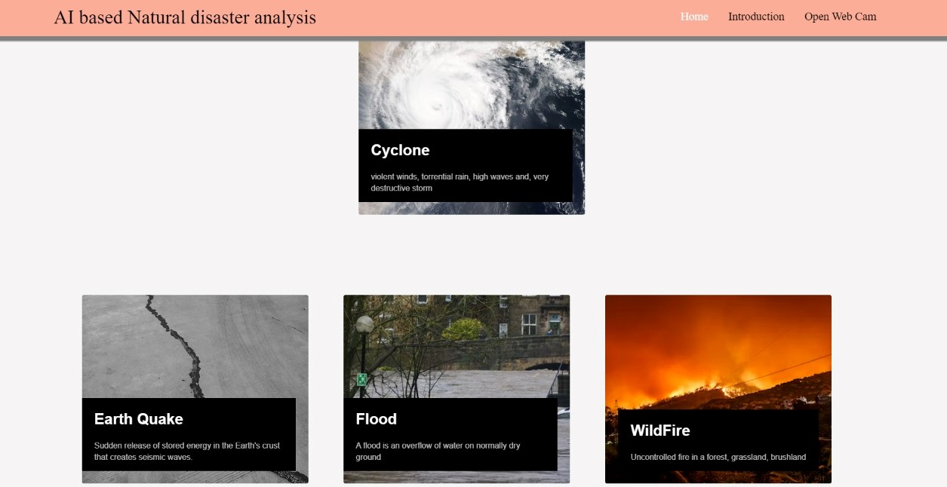

**INTRO PAGE:**

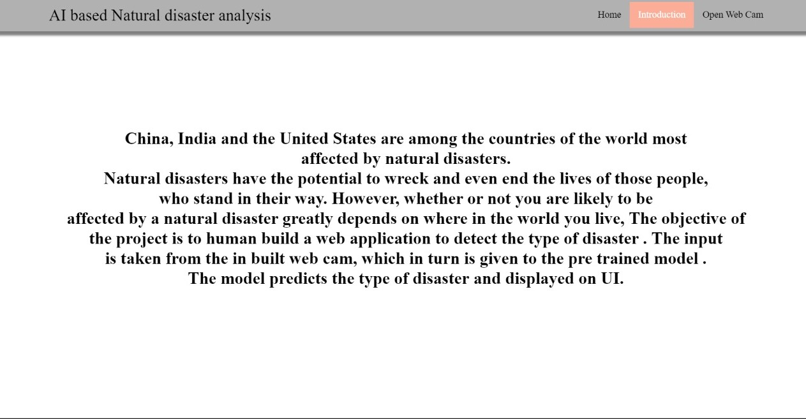

**OUTPUT:**

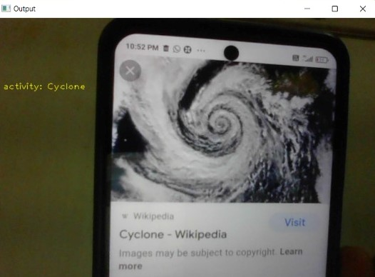

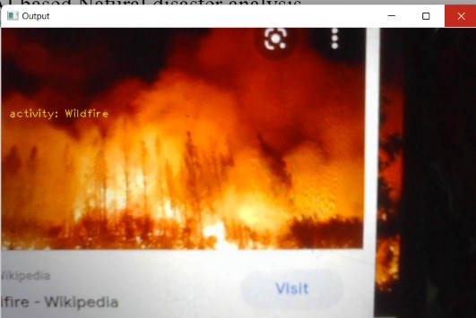

**10. ADVANTAGES & DISADVANTAGES:**

###### **ADVANTAGES:**

i. The use of AI to forecast natural disasters would save millions of lives. Furthermore, the information evaluated by AI-powered systems can aid in understanding the scale and patterns of natural catastrophes such as floods, earthquakes, and tsunamis, which would aid in improved infrastructure development in disaster-prone areas.

ii. Disaster management plays an integral role in keeping communities safe. It involves coordinating the resources, such as pollution control systems, and responsibilities, such as following best practice policies, needed to prevent, prepare for, respond to, and recover from emergencies

###### **DISADVANTAGES:**

i. A forest fire is a natural disaster that cannot be forecasted.

ii. Sometimes the prediction may fail and result in huge loss.

**11. CONCLUSION:**

Natural disasters inflict severe damage on almost the entire spectrum of social and natural habitats, ranging from housing and shelter, water, food, health, sanitation, and waste management to information and communication networks, supply of power and energy, and transportationinfrastructure.So far, different approaches to landslide

susceptibility zonation have been proposed, but what is certain is that all these methods can provide accurate results with minimal data and costs and at very low levels. Combining thesemodels with GIS and RS systems not only increases the accuracy of dealing with complex issues and uncertainties, but also leads to the emergence and development of new theories and methods in a variety of issues.

**12. FUTURE SCOPE:**

The term “Natural Disaster” encompasses the complete realm of disaster-related activities. Traditionally people tend to think of disaster management only in terms of the post-disaster actions taken by relief and reconstruction officials; yet disaster management covers a much broader scope, and many modern disaster managers may find themselves far more involved in pre-disaster activities than in post-disaster response. Those are:

1. The refugee field of disaster management is highly specialized and requires not only many development skills but also a broader awareness of political, legal, and humanitarian issues.
2. DM aims and objectives, elements, Natural/man-made Disasters, Victims, Relief Systems.
3. Phases of Disaster Response/Relief Operations, Government’s Role.

**To Safeguard and make available vital materials, supplies and equipment to ensure the safety and recovery of records from predictable disasters**.To reduce the risk of disasters caused by human error, deliberate destruction, and building or equipment failures. Be better prepared to recover from a major natural catastrophe.Our model help to build preparedness for threats and hazards by providing a low-risk, cost- effective environment to: **Test and validate plans, policies, procedures and capabilities**. Identify resource requirements, capability gaps, strengths, areas for improvement, and potential best practices. Disaster management aims to reduce, or avoid, the potential losses from hazards, assure prompt and appropriate assistance to victims of disaster, and achieve rapid and effective recovery. Disaster Risk Management includes the sum total of all activities, programs and measures which can be taken up before, during and after a disaster with the purpose to avoid a disaster, reduce its impact or recover from its losses.

**13. APPENDIX:**

**HTML CODE :**

**Home html;**

<html>

<script>

</script>

<style>

.header { position: relative;

top:0;

margin:0px;

z-index: 1;

left: 0px;

right: 0px;

position: fixed;

background-color: #FCAD98 ;

color: white;

box-shadow: 0px 8px 2px grey;

overflow: hidden;

padding-left:20px;

font-family: 'Josefin Sans';

font-size: 2vw;

width: 100%;

height:8%;

text-align: center;

}

.topnav {

overflow: hidden;

background-color: #FCAD98;

}

.topnav-right a {

float: left;

color: black;

text-align: center;

padding: 14px 16px;

text-decoration: none;

font-size: 18px;

}

.topnav-right a:hover {

background-color: #FCAD98;

color: black;

}

.topnav-right a.active {

background-color: #FCAD98;

color: white;

}

.topnav-right {

float: right;

padding-right:100px;

}

body {

background-image: -webkit-linear-gradient(90deg, skyblue 0%, steelblue 100%);

background-image: url("");

background-size: cover;

background-attachment: fixed;

background-size: 100% 100%;

background-color: ;

background-repeat: no-repeat;

background-size:cover;

background-position: 0px 0px;

}

.button {

background-color: #091425;

border: none;

color: white;

padding: 15px 32px;

text-align: center;

text-decoration: none;

display: inline-block;

font-size: 12px;

border-radius: 16px;

}

.button:hover {

box-shadow: 0 12px 16px 0 rgba(0,0,0,0.24), 0 17px 50px 0 rgba(0,0,0,0.19);

}

form {border: 3px solid #f1f1f1; margin-left:400px;margin-right:400px;}

input[type=text], input[type=password] {

width: 100%;

padding: 12px 20px;

display: inline-block;

margin-bottom:18px;

border: 1px solid #ccc;

box-sizing: border-box;

}

button {

background-color: #091425;

color: white;

padding: 14px 20px;

margin-bottom:10px;

border: none;

cursor: pointer;

width: 17%;

border-radius:4px;

font-family:Montserrat;

}

button:hover {

opacity: 0.8;

}

.cancelbtn {

width: auto;

padding: 10px 18px;

background-color: #f44336;

}

.imgcontainer {

text-align: center;

margin: 24px 0 12px 0;

}

img.avatar {

width: 30%;

border-radius: 50%;

}

.container {

padding: 16px;

}

span.psw {

float: right;

padding-top: 16px;

}

/* Change styles for span and cancel button on extra small screens */

@media screen and (max-width: 300px) {

span.psw {

display: block;

float: none;

}

.cancelbtn {

width: 100%;

}

}

.home{

margin:80px;

width: 84%;

height: 500px;

padding-top:10px;

padding-left: 30px;

}

.login{

margin:80px;

box-sizing: content-box;

width: 84%;

height: 420px;

padding: 30px;

border: 10px solid blue;

}

.left,.right{

box-sizing: content-box;

height: 400px;

margin:20px;

border: 10px solid blue;

}

.mySlides {display: none;}

img {vertical-align: middle;}

/* Slideshow container */

.slideshow-container {

max-width: 1000px;

position: relative;

margin: auto;

}

/* Caption text */

.text {

color: #f2f2f2;

font-size: 15px;

padding: 8px 12px;

position: absolute;

bottom: 8px;

width: 100%;

text-align: center;

}

/* The dots/bullets/indicators */

.dot {

height: 15px;

width: 15px;

margin: 0 2px;

background-color: #bbb;

border-radius: 50%;

display: inline-block;

transition: background-color 0.6s ease;

}

.active {

background-color: #FCAD98;

}

/* Fading animation */

.fade {

-webkit-animation-name: fade;

-webkit-animation-duration: 1.5s;

animation-name: fade;

animation-duration: 1.5s;

}

@-webkit-keyframes fade {

from {opacity: .4}

to {opacity: 1}

}

@keyframes fade {

from {opacity: .4}

to {opacity: 1}

}

/* On smaller screens, decrease text size */

@media only screen and (max-width: 300px) {

.text {font-size: 11px}

}

@import url('https://fonts.googleapis.com/css2?family=Poppins&display=swap');

* {

box-sizing: border-box;

}

body {

min-height: 100vh;

margin: 0;

color: #fff;

font-family: 'Poppins',sans-serif;

display: flex;

align-items: center;

justify-content: center;

background-color: #f5f5f5;

}

.container {

max-width: 1376px;

margin: auto;

padding: 2rem 1.5rem;

}

.cards {

display: flex;

flex-wrap: wrap;

align-items: center;

justify-content: center;

}

.card {

cursor: pointer;

background-color: transparent;

height: 300px;

perspective: 1000px;

margin: 1rem;

align-items: center;

justify-content: center;

}

.card h3 {

border-bottom: 1px #fff solid;

padding-bottom: 10px;

margin-bottom: 10px;

text-align: center;

font-size: 1.6rem;

word-spacing: 3px;

}

.card p{

opacity: 0.75;

font-size: 0.8rem;

line-height: 1.4;

}

.card img {

width: 360px;

height: 300px;

object-fit: cover;

border-radius: 3px;

}

.card-inner {

position: relative;

width: 360px;

height: 100%;

transition: transform 0.9s;

transform-style: preserve-3d;

}

.card:hover .card-inner {

transform: rotateY(180deg);

}

.card-front,

.card-back {

position: absolute;

width: 360px;

height: 100%;

-webkit-backface-visibility: hidden;

backface-visibility: hidden;

}

.card-back {

background-color: #222;

color: #fff;

padding: 1.5rem;

transform: rotateY(180deg);

}

.text-block {

position: absolute;

bottom: 20px;

right: 20px;

background-color: black;

color: white;

padding-left: 20px;

padding-right: 20px;

}

</style>

<body>

<div class="header">

<div style="width:50%;float:left;font-size:2vw;text-align:left;color:black; padding-top:1%;padding-left:5%;">AI based Natural disaster analysis</div>

<div class="topnav-right"style="padding-top:0.5%;">

<a class="active" href="/home">Home</a>

<a href="/intro">Introduction</a>

<a href="/upload">Open Web Cam</a>

</div>

</div>

<div class="container">

<div class="cards">

<div class="card">

<div class="card-inner">

<div class="card-front">

alt="">

<div class="text-block">

<h2>Cyclone</h2>

<p>violent winds, torrential rain, high waves and, very destructive storm</p>

</div>

</div>

<div class="card-back">

<h3>Cyclone</h3>

<p>The effects of tropical cyclones include heavy rain, strong wind, large storm surges near landfall, and tornadoes. The destruction from a tropical cyclone, such as a hurricane or tropical storm, depends mainly on its intensity, its size, and its location.</p>

</div>

</div>

</div>

<div class="container">

<div class="cards">

<div class="card">

<div class="card-inner">

<div class="card-front">

alt="">

<div class="text-block">

<h2>Earth Quake</h2>

<p>Sudden release of stored energy in the Earth's crust that creates seismic waves.</p>

</div>

</div>

<div class="card-back">

<h3>Earth Quake</h3>

<p>Earthquakes are usually caused when rock underground suddenly breaks along a fault. This sudden release of energy causes the seismic waves that make the ground shake. ... During the earthquake and afterward, the plates or blocks of rock start moving, and they continue to move until they get stuck again.</p>

</div>

</div>

</div>

<div class="container">

<div class="cards">

<div class="card">

<div class="card-inner">

<div class="card-front">

alt="">

<div class="text-block">

<h2>Flood</h2>

<p>A flood is an overflow of water on normally dry ground</p>

</div>

</div>

<div class="card-back">

<h3>Flood</h3>

<p>During heavy rain, the storm drains can become overwhelmed or plugged by debris and flood the roads and buildings nearby. Low spots, such as underpasses, underground parking garages, basements, and low water crossings can become death traps. Areas near rivers are at risk from floods.</p>

</div>

</div>

</div>

<div class="container">

<div class="cards">

<div class="card">

<div class="card-inner">

<div class="card-front">

alt="">

<div class="text-block">

<h2>WildFire</h2>

<p>Uncontrolled fire in a forest, grassland, brushland</p>

</div>

</div>

<div class="card-back">

<h3>Wildfire</h3>

<p>Wildfires can be caused by an accumulation of dead matter (leaves, twigs, and trees) that can create enough heat in some instances to spontaneously combust and ignite the surrounding area. Lightning strikes the earth over 100,000 times a day. 10 to 20% of these lightning strikes can cause fire.</p>

</div>

</div>

</div>

</body>

<html>

**INTRO HTML:**

<html>

<script>

</script>

<style>

.header { position: relative;

top:0;

margin:0px;

z-index: 1;

left: 0px;

right: 0px;

position: fixed;

background-color: rgba(100, 100, 100, 0.5) ;

color: white;

box-shadow: 0px 8px 4px grey;

overflow: hidden;

padding-left:20px;

font-family: 'Josefin Sans';

font-size: 2vw;

width: 100%;

height:8%;

text-align: center;

}

.topnav {

overflow: hidden;

background-color: #FCAD98;

}

.topnav-right a {

float: left;

color: black;

text-align: center;

padding: 14px 16px;

text-decoration: none;

font-size: 18px;

}

.topnav-right a:hover {

background-color: #FCAD98;

color: black;

}

.topnav-right a.active {

background-color: #FCAD98;

color: white;

}

.topnav-right {

float: right;

padding-right:100px;

}

body {

background-color: ;

background-repeat: no-repeat;

background-size:cover;

background-size: cover;

background-position: 0px 0px;

}

.button {

background-color: #091425;

border: none;

color: white;

padding: 15px 32px;

text-align: center;

text-decoration: none;

display: inline-block;

font-size: 12px;

border-radius: 16px;

}

.button:hover {

box-shadow: 0 12px 16px 0 rgba(0,0,0,0.24), 0 17px 50px 0 rgba(0,0,0,0.19);

}

form {border: 3px solid #f1f1f1; margin-left:400px;margin-right:400px;}

input[type=text], input[type=password] {

width: 100%;

padding: 12px 20px;

display: inline-block;

margin-bottom:18px;

border: 1px solid #ccc;

box-sizing: border-box;

}

button {

background-color: #091425;

color: white;

padding: 14px 20px;

margin-bottom:10px;

border: none;

cursor: pointer;

width: 17%;

border-radius:4px;

font-family:Montserrat;

}

button:hover {

opacity: 0.8;

}

.cancelbtn {

width: auto;

padding: 10px 18px;

background-color: #f44336;

}

.imgcontainer {

text-align: center;

margin: 24px 0 12px 0;

}

img.avatar {

width: 30%;

border-radius: 50%;

}

.container {

padding: 16px;

}

span.psw {

float: right;

padding-top: 16px;

}

/* Change styles for span and cancel button on extra small screens */

@media screen and (max-width: 300px) {

span.psw {

display: block;

float: none;

}

.cancelbtn {

width: 100%;

}

}

.home{

margin:80px;

width: 84%;

height: 500px;

padding-top:10px;

padding-left: 30px;

}

.login{

margin:80px;

box-sizing: content-box;

width: 84%;

height: 420px;

padding: 30px;

border: 10px solid blue;

}

.left,.right{

box-sizing: content-box;

height: 400px;

margin:20px;

border: 10px solid blue;

}

.mySlides {display: none;}

img {vertical-align: middle;}

/* Slideshow container */

.slideshow-container {

max-width: 1000px;

position: relative;

margin: auto;

}

/* Caption text */

.text {

color: #f2f2f2;

font-size: 15px;

padding: 8px 12px;

position: absolute;

bottom: 8px;

width: 100%;

text-align: center;

}

/* The dots/bullets/indicators */

.dot {

height: 15px;

width: 15px;

margin: 0 2px;

background-color: #bbb;

border-radius: 50%;

display: inline-block;

transition: background-color 0.6s ease;

}

.active {

background-color: #FCAD98;

}

/* Fading animation */

.fade {

-webkit-animation-name: fade;

-webkit-animation-duration: 1.5s;

animation-name: fade;

animation-duration: 1.5s;

}

@-webkit-keyframes fade {

from {opacity: .4}

to {opacity: 1}

}

@keyframes fade {

from {opacity: .4}

to {opacity: 1}

}

/* On smaller screens, decrease text size */

@media only screen and (max-width: 300px) {

.text {font-size: 11px}

}

@import url("https://fonts.googleapis.com/css?family=Montserrat&display=swap");

* {

padding: 0;

margin: 0;

}

body {

height: 100vh;

display: flex;

flex-direction: column;

justify-content: center;

align-items: center;

}

h1 {

font-family: "Montserrat Medium";

max-width: 90ch;

text-align: center;

transform: scale(0.94);

animation: scale 3s forwards cubic-bezier(0.5, 1, 0.89, 1);

}

@keyframes scale {

100% {

transform: scale(1);

}

}

span {

display: inline-block;

opacity: 0;

filter: blur(4px);

}

span:nth-child(1) {

animation: fade-in 1s 0.1s forwards cubic-bezier(0.11, 0, 0.5, 0);

}

span:nth-child(2) {

animation: fade-in 0.8s 0.2s forwards cubic-bezier(0.11, 0, 0.5, 0);

}

span:nth-child(3) {

animation: fade-in 0.8s 0.3s forwards cubic-bezier(0.11, 0, 0.5, 0);

}

span:nth-child(4) {

animation: fade-in 0.8s 0.4s forwards cubic-bezier(0.11, 0, 0.5, 0);

}

span:nth-child(5) {

animation: fade-in 0.8s 0.5s forwards cubic-bezier(0.11, 0, 0.5, 0);

}

span:nth-child(6) {

animation: fade-in 0.8s 0.6s forwards cubic-bezier(0.11, 0, 0.5, 0);

}

span:nth-child(7) {

animation: fade-in 0.8s 0.7s forwards cubic-bezier(0.11, 0, 0.5, 0);

}

span:nth-child(8) {

animation: fade-in 0.8s 0.8s forwards cubic-bezier(0.11, 0, 0.5, 0);

}

span:nth-child(9) {

animation: fade-in 0.8s 0.9s forwards cubic-bezier(0.11, 0, 0.5, 0);

}

span:nth-child(10) {

animation: fade-in 0.8s 1s forwards cubic-bezier(0.11, 0, 0.5, 0);

}

span:nth-child(11) {

animation: fade-in 0.8s 1.1s forwards cubic-bezier(0.11, 0, 0.5, 0);

}

span:nth-child(12) {

animation: fade-in 0.8s 1.2s forwards cubic-bezier(0.11, 0, 0.5, 0);

}

span:nth-child(13) {

animation: fade-in 0.8s 1.3s forwards cubic-bezier(0.11, 0, 0.5, 0);

}

span:nth-child(14) {

animation: fade-in 0.8s 1.4s forwards cubic-bezier(0.11, 0, 0.5, 0);

}

span:nth-child(15) {

animation: fade-in 0.8s 1.5s forwards cubic-bezier(0.11, 0, 0.5, 0);

}

span:nth-child(16) {

animation: fade-in 0.8s 1.6s forwards cubic-bezier(0.11, 0, 0.5, 0);

}

span:nth-child(17) {

animation: fade-in 0.8s 1.7s forwards cubic-bezier(0.11, 0, 0.5, 0);

}

span:nth-child(18) {

animation: fade-in 0.8s 1.8s forwards cubic-bezier(0.11, 0, 0.5, 0);

}

span:nth-child(19) {

animation: fade-in 0.8s 1.9s forwards cubic-bezier(0.11, 0, 0.5, 0);

}

span:nth-child(20) {

animation: fade-in 0.8s 2.0s forwards cubic-bezier(0.11, 0, 0.5, 0);

}

span:nth-child(21) {

animation: fade-in 0.8s 2.1s forwards cubic-bezier(0.11, 0, 0.5, 0);

}

span:nth-child(22) {

animation: fade-in 0.8s 2.2s forwards cubic-bezier(0.11, 0, 0.5, 0);

}

span:nth-child(23) {

animation: fade-in 0.8s 2.3s forwards cubic-bezier(0.11, 0, 0.5, 0);

}span:nth-child(24) {

animation: fade-in 0.8s 2.4s forwards cubic-bezier(0.11, 0, 0.5, 0);

}span:nth-child(25) {

animation: fade-in 0.8s 2.5s forwards cubic-bezier(0.11, 0, 0.5, 0);

}span:nth-child(26) {

animation: fade-in 0.8s 2.6s forwards cubic-bezier(0.11, 0, 0.5, 0);

}span:nth-child(27) {

animation: fade-in 0.8s 2.7s forwards cubic-bezier(0.11, 0, 0.5, 0);

}span:nth-child(28) {

animation: fade-in 0.8s 2.8s forwards cubic-bezier(0.11, 0, 0.5, 0);

}

@keyframes fade-in {

100% {

opacity: 1;

filter: blur(0);

}

}

</style>

<body>

<h1>

</h1>

<!--Brian Tracy-->

<div class="header">

<div style="width:50%;float:left;font-size:2vw;text-align:left;color:black; padding-top:1%;padding-left:5%;">AI based Natural disaster analysis</div>

<div class="topnav-right"style="padding-top:0.5%;">

<a href="/home">Home</a>

<a class="active" href="/intro">Introduction</a>

<a href="/upload">Open Web Cam</a>

</div>

</div>

</body>

</html>

**UPLOAD HTML:**

<html lang="en">

<head>

<title>Register</title>

<link href="https://cdn.bootcss.com/bootstrap/4.0.0/css/bootstrap.min.css" rel="stylesheet">

<style>

.header { position: relative;

top:0;

margin:0px;

z-index: 1;

left: 0px;

right: 0px;

position: fixed;

background-color: #F36262 ;

color: white;

box-shadow: 0px 8px 4px grey;

overflow: hidden;

padding-left:20px;

font-family: 'Josefin Sans';

font-size: 2vw;

width: 100%;

height:8%;

text-align: center;

}

.topnav {

overflow: hidden;

background-color: #FCAD98;

}

.topnav-right a {

float: left;

color: black;

text-align: center;

padding: 14px 16px;

text-decoration: none;

font-size: 18px;

}

.topnav-right a:hover {

background-color: #FCAD98;

color: black;

}

.topnav-right a.active {

background-color: #FCAD98;

color: white;

}

.topnav-right {

float: right;

padding-right:100px;

}

body {

background-color: ;

background-repeat: no-repeat;

background-size:cover;

background-image: url("https://i.pinimg.com/originals/b2/1d/c6/b21dc69346915015bc4e19bd502f401b.gif");

background-size: cover;

background-position: 0px 0px;

}

.button {

background-color: #091425;

border: none;

color: white;

padding: 15px 32px;

text-align: center;

text-decoration: none;

display: inline-block;

font-size: 12px;

border-radius: 16px;

}

.button:hover {

box-shadow: 0 12px 16px 0 rgba(0,0,0,0.24), 0 17px 50px 0 rgba(0,0,0,0.19);

}

form {border: 3px solid #f1f1f1; margin-left:400px;margin-right:400px;}

input[type=text], input[type=password] {

width: 100%;

padding: 12px 20px;

display: inline-block;

margin-bottom:18px;

border: 1px solid #ccc;

box-sizing: border-box;

}

button {

background-color: #091425;

color: white;

padding: 14px 20px;

margin-bottom:10px;

border: none;

cursor: pointer;

width: 17%;

border-radius:4px;

font-family:Montserrat;

}

button:hover {

opacity: 0.8;

}

.cancelbtn {

width: auto;

padding: 10px 18px;

background-color: #f44336;

}

.imgcontainer {

text-align: center;

margin: 24px 0 12px 0;

}

img.avatar {

width: 30%;

border-radius: 50%;

}

.container {

padding: 16px;

}

span.psw {

float: right;

padding-top: 16px;

}

/* Change styles for span and cancel button on extra small screens */

@media screen and (max-width: 300px) {

span.psw {

display: block;

float: none;

}

.cancelbtn {

width: 100%;

}

}

.home{

margin:80px;

width: 84%;

height: 500px;

padding-top:10px;

padding-left: 30px;

}

.login{

margin:80px;

box-sizing: content-box;

width: 84%;

height: 420px;

padding: 30px;

border: 10px solid blue;

}

.left,.right{

box-sizing: content-box;

height: 400px;

margin:20px;

border: 10px solid blue;

}

.mySlides {display: none;}

img {vertical-align: middle;}

/* Slideshow container */

.slideshow-container {

max-width: 1000px;

position: relative;

margin: auto;

}

/* Caption text */

.text {

color: #f2f2f2;

font-size: 15px;

padding: 8px 12px;

position: absolute;

bottom: 8px;

width: 100%;

text-align: center;

}

/* The dots/bullets/indicators */

.dot {

height: 15px;

width: 15px;

margin: 0 2px;

background-color: #bbb;

border-radius: 50%;

display: inline-block;

transition: background-color 0.6s ease;

}

.active {

background-color: #FCAD98;

}

/* Fading animation */

.fade {

-webkit-animation-name: fade;

-webkit-animation-duration: 1.5s;

animation-name: fade;

animation-duration: 1.5s;

}

@-webkit-keyframes fade {

from {opacity: .4}

to {opacity: 1}

}

@keyframes fade {

from {opacity: .4}

to {opacity: 1}

}

/* On smaller screens, decrease text size */

@media only screen and (max-width: 300px) {

.text {font-size: 11px}

}

.bar

{

margin: 0px;

padding:20px;

background-color:white;

opacity:0.6;

color:black;

font-family:'Roboto',sans-serif;

font-style: italic;

border-radius:20px;

font-size:25px;

}

a

{

color:grey;

float:right;

text-decoration:none;

font-style:normal;

padding-right:20px;

}

a:hover{

background-color:black;

color:white;

border-radius:15px;0

font-size:30px;

padding-left:10px;

}

body

{

background-image: url("https://images.unsplash.com/photo-1532883130016-f3d311140ba8?ixid=MXwxMjA3fDB8MHxwaG90by1wYWdlfHx8fGVufDB8fHw%3D&ixlib=rb-1.2.1&auto=format&fit=crop&w=1050&q=80");

background-size: cover;

}

p

{

color:white;

font-style:italic;

font-size:30px;

}

</style>

</head>

<body>

<div class="header">

<div style="width:50%;float:left;font-size:2vw;text-align:left;color:black; padding-top:1%;padding-left:5%;">AI based Natural disaster analysis</div>

<div class="topnav-right"style="padding-top:0.5%;">

<a href="/home">Home</a>

<a href="/intro">Introduction</a>

<a class="active" href="/upload">Open Web Cam</a>

</div>

</div>

</body>

**PYTHON CODE:**

from flask import Flask, render_template, request, redirect, url_for

import cv2

from tensorflow.keras.models import load_model

import numpy as np

from werkzeug.utils import secure_filename

app = Flask(__name__, template_folder="templates")

model = load_model('disaster.h5')

print("Loaded model from disk")

@app.route('/', methods=['GET'])

def index():

return render_template('home.html')

@app.route('/home', methods=['GET'])

def home():

return render_template('home.html')

@app.route('/intro', methods=['GET'])

def about():

return render_template('intro.html')

@app.route('/upload', methods=['GET', 'POST'])

def predict():

print("[INFO] starting video stream...")

vs = cv2.VideoCapture(0)

(W, H) = (None, None)

while True:

(grabbed, frame) = vs.read()

if not grabbed:

break

if W is None or H is None:

(H, W) = frame.shape[:2]

output = frame.copy()

frame = cv2.cvtColor(frame, cv2.COLOR_BGR2RGB)

frame = cv2.resize(frame, (64, 64))

x = np.expand_dims(frame, axis=0)

result = np.argmax(model.predict(x), axis=-1)

index = ['Cyclone', 'Earthquake', 'Flood', 'Wildfire']

result = str(index[result[0]])

cv2.putText(output, "activity: {}".format(result), (10, 120), cv2.FONT_HERSHEY_PLAIN,

1, (0, 255, 255), 1)

cv2.imshow("Output", output)

key = cv2.waitKey(1) & 0xFF

if key == ord("q"):

break

print("[INFO] cleaning up...")

vs.release()

cv2.destroyAllWindows()

return render_template("upload.html")

@app.route('/file', methods=['POST', 'GET'])

def video():

if request.method == 'POST':

uploaded_file = request.files['file1']

if uploaded_file.filename != '':

vid_name = str(uploaded_file.filename)

print(vid_name + "Uploaded_Succesfully")

uploaded_file.save(uploaded_file.filename)

vs = cv2.VideoCapture(vid_name)

if (vs.isOpened() == False):

print("Error opening video stream or file")

(W, H) = (None, None)

while True:

(grabbed, frame) = vs.read()

if not grabbed:

break

if W is None or H is None:

(H, W) = frame.shape[:2]

output = frame.copy()

frame = cv2.cvtColor(frame, cv2.COLOR_BGR2RGB)

frame = cv2.resize(frame, (64, 64))

x = np.expand_dims(frame, axis=0)

result = np.argmax(model.predict(x), axis=-1)

index = ['Cyclone', 'Earthquake', 'Flood', 'Wildfire']

result = str(index[result[0]])

cv2.putText(output, "activity: {}".format(

result), (10, 120), cv2.FONT_HERSHEY_PLAIN, 1, (0, 255, 255), 1)

cv2.imshow("Output", output)

key = cv2.waitKey(1) & 0xFF

if key == ord("q"):

break

print("[INFO] cleaning up...")

vs.release()

cv2.destroyAllWindows()

return render_template("file.html")

@app.route('/image', methods=['POST', 'GET'])

def image():

resulttext = ''

if request.method == 'POST':

uploaded_file = request.files['imgfile']

if uploaded_file.filename != '':

img_name = str(uploaded_file.filename)

print(img_name + "Uploaded Succesfully")

uploaded_file.save(uploaded_file.filename)

from tensorflow.keras.models import load_model

from keras.preprocessing import image

model = load_model("disaster.h5")

img = image.load_img(img_name, grayscale=False,

target_size=(64, 64))

x = image.img_to_array(img)

x = np.expand_dims(x, axis=0)

pred = model.predict_classes(x)

index = ['Cyclone', 'Earthquake', 'Flood', 'Wildfire']

result = index[pred[0]]

resulttext = result

return render_template('image.html', result_text=resulttext)

if __name__ == '__main__':

app.run(host='127.0.0.1', port=8000, debug=True)

**GitHub & Project Demo Link:**

https://github.com/IBM-EPBL/IBM-Project-685-1658315166

https://drive.google.com/file/d/1hAcJq1y0fng2sHoflB5lx3WJljytT8Jz/view?usp=sharing